December 10th, 2006
Hi
Last week, I started gym exercise again. Did three sessions with weights and two on the treadmill. Not back to normal though, with the runs being rather slower. Sometimes a bit tired on finishing. Went for a shorter run yesterday, most of it being a route Leonie did with me earlier this year (Tai Tong / end of road / down to reservoir / back through the picnic ground – didn’t do the loop on the other side of the reservoir). At 1 hr 43 min, it was slower, especially on the uphill bits.
The government announced that it has finally decided to scrap plans to introduce a GST tax, after virtually the whole community was against it. Now its salted fish that is infected, this time from the Philippines. The earlier infected fish was freshwater fish from China. The election is being held today for the 800-person committee that will elect the next CE next year.

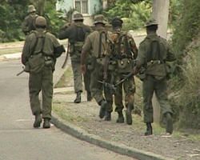
On Thursday, I went again to the dermatologist. He was quite surprised that the area of my face affected by the cream was so large. I will apply the cream for another 4 weeks. When checking my legs he commented that they were rather dry (it is the dry season after all was my reaction!). He commented that dry skin could lead to future eczema so he also prescribed some moisturiser.

The Army in Fiji finally removes the government and takes over.

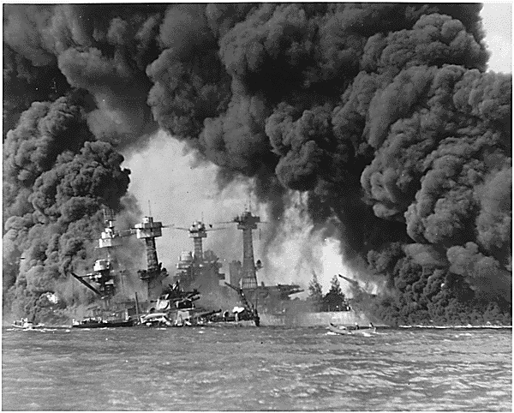
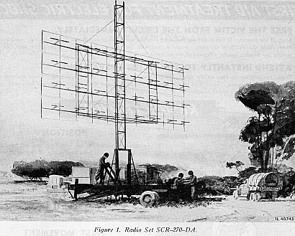
Friday in HK (Thursday in the US) was the 65th anniversary of the attack on Pearl Harbor. (Dec 7th in Hawaii). By coincidence, I had been watching a TV series on the development of air power and in one it was talking about radar, the secrets of which the British gave to the US, and which was installed near Pearl Harbor. The operators correctly identified approaching aircraft but this was dismissed by the ‘brass’ who said they had picked up US bombers returning from the US mainland. (Interesting too other things that the British just handed over free to the US, including the Whittle jet engine, and the movable tail without which aircraft could not go through the sound barrier. Perhaps all this largesse was a ‘quid-pro-quo’ for all the supplies the US gave to the UK during the war.)
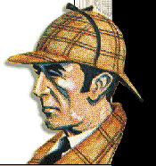
The 2nd round of the World iRB 7s was held in George, SA. NZ won, beating SA 24 - 17 in final. So NZ and SA are now equal top in terms of points.
The invitation from Stanford University came out for new book. However, this time they will be charging US$20 for the paper version. For that price, one could buy the book, which will be other stories from Arthur Conan Doyle.
That’s about it for now. I really cannot think of anything else to write about.

Cheers

